Cloud Computing for Data Analysis
Group Activity 01
Task 2 – Using AWS EMR Cluster, Simple HDFS Commands, Create and Search through a file on AWS Cluster

Please complete Task 1 before this task. In this activity, you are going to setup and log into the AWS cluster.

Step1: Go to the following link to setup the AWS educate account https://aws.amazon.com/education/awseducate/

Step2: Click on “Join AWS Educate”

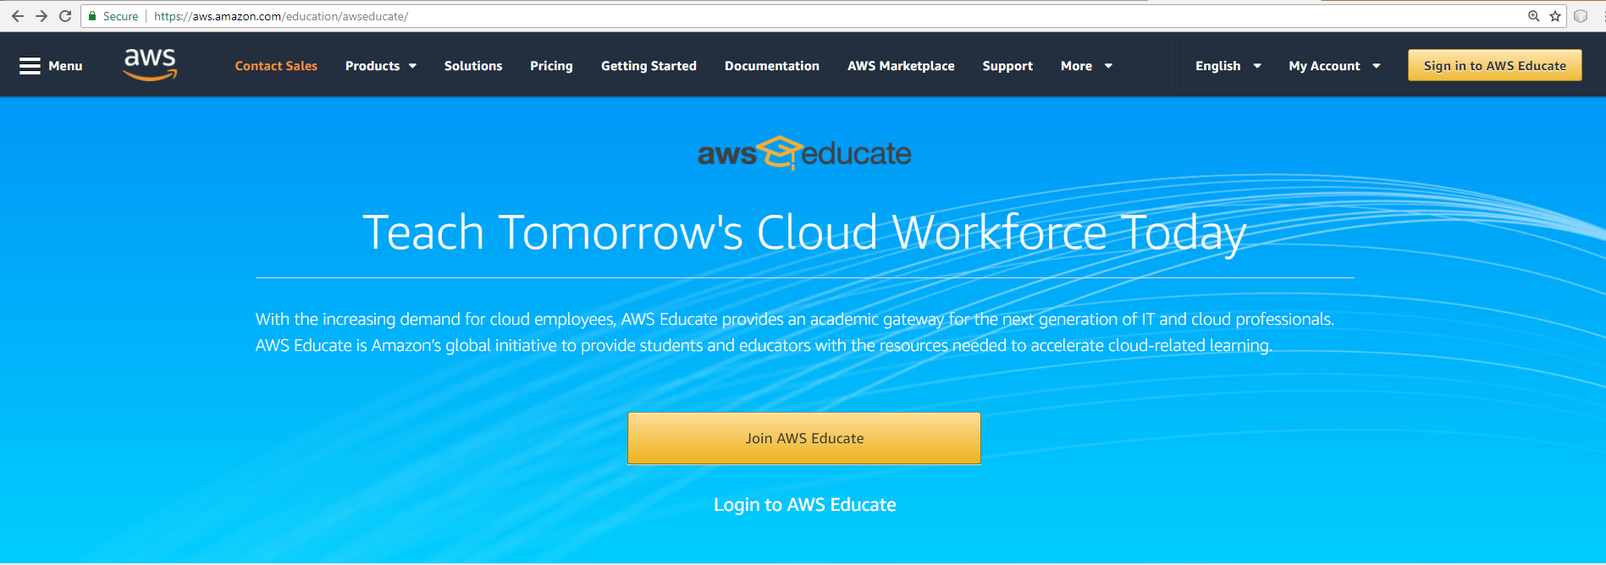

Step3: On the resulting page select “Student”

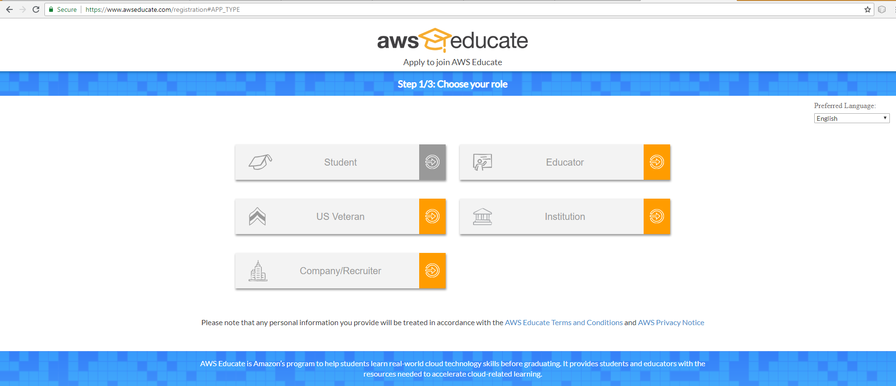

Step4: Fill in the required details on the “Tell us about yourself” page. In the tab where it says Promo Code please follow the below NOTE.

*********
NOTE: You must enter Registration Code, sent to your e-mail address (*after* the Course Add/Drop Date). This Code gives student free $ on AWS, to complete the Course Assignments. If you do not enter this code, when creating your account, your Credit Card may be charged by AWS.

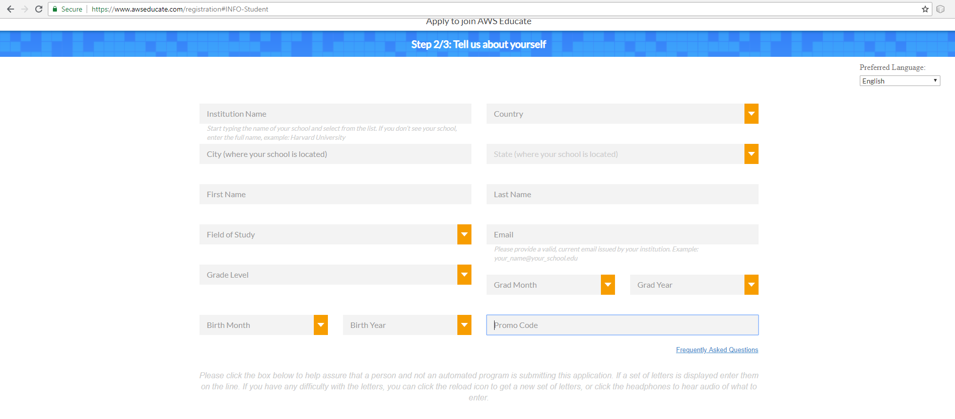

REFER THIS VIDEO TO SETUP A CLUSTER IN AWS, SETUP S3 INSTANCE AND LOGIN TO THE MASTER NODE: https://www.youtube.com/watch?v=_A_xEtd2OIM

Log in to AWS Hadoop Cluster
To log into this cluster, you need following software:
PuTTY (for Windows): Go to http://www.putty.org/ and select Download PuTTY here heading. Select putty.exe and an .exe file will be downloaded. See more PuTTY instructions at: http://docs.aws.amazon.com/AWSEC2/latest/UserGuide/putty.html
This software acts as a terminal of the remote machine.

SSH client (for Macintosh)

Simple HDFS Commands

Files in HDFS can be accessed using hadoop commands. Similarly, the output of your code will be present in HDFS (hadoop distributed filesystem). In dsba cluster, /user/username/ is a home directory of all your files and folders. As you did in Task 1, you can run following Hadoop commands in dsba cluster also:

To list all files and folders in the home directory of HDFS, use:
hadoop fs -ls /user/
To copy a file from AWS S3 into HDFS home directoy, use:
aws s3 cp s3://BUCKET_NAME/filename /user/
To copy a file from HDFS home directoy into AWS S3, use:
aws s3 cp /user/filename s3://BUCKET_NAME/

To open a file in HDFS, use:
hadoop fs -cat /user/filename
fs – denotes File System to represent that the command is accessing files from HDFS
All basic HDFS commands can be found here: https://hadoop.apache.org/docs/r2.4.1/hadoop-project-dist/hadoop-common/FileSystemShell.html

Create and Search through a file on DSBA Hadoop

- Create a file ListOfInputActionRules.txt on your laptop
- Copy and paste following lines in ListOfInputActionRules.txt
(a, a1->a2) ^ (c = c2) -> (f, f1->f0) [2, 50%]
(a, a1->a3) ^ (b, ->b1) -> (f, f1->f0) [3, 75%]
(a, a1->a3) ^ (c = c2) -> (f, f1->f0) [1, 80%]
(a, ->a3) ^ (b, b2->b1) -> (f, f1->f0) [3, 50%]

- Login to AWS and open S3
- Upload ListOfInputActionRules.txt to the S3 bucket.
- Log into the master node of the created AWS cluster via Terminal (in Macintosh) or PuTTY (in Windows) - to run commands .
- Run simple text processing on the ListOfInputActionRules using Grep command:
- See https://wiki.apache.org/hadoop/Grep to learn about Grep command
- To return all lines of text which contain the word ‘a1’ and store in the folder Out4Grep01 S3, run the command:

hadoop org.apache.hadoop.examples.Grep s3://BUCKET_NAME/ListOfInputActionRules.txt s3://BUCKET_NAME/Out4Grep01 .*a1.*

(NOTE: If the output folder Out4Grep01 does not exist, Hadoop will create it automatically . )
We can download the output from AWS S3 to our local machine
- Repeat Steps 1. – 8. using the Mammals book text file below, and return all lines of text which contain the word ‘mammal’

http://webpages.uncc.edu/aatzache/ITCS6190/Exercises/03_MammalsBook_Text_34848.txt.utf8.txt
- Save all the text (all commands, all outputs, results) from your Terminal window into Text file, and upload to Canvas.
- Delete/Terminate the AWS cluster and delete all files from S3 when finished, otherwise Amazon will charge your Credit Card

